# Gesture Based MIDI Controller Instructions

**CC Configurations**

The CC Commands follow a typical CC list (<http://nickfever.com/music/midi-cc-list>), the global variables in the application have been mapped to the following undefined CC commands as follows:

Global volume: CC 14 – Channel 1

Global tap tempo: CC 15 – Channel 1

**Display**

Each track has its own control panel as follows:

Control axis for selected slot

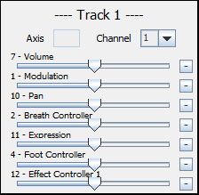

Slot 1

Select channel

Slot 2

Slot 3

Slot 4

Change action

Slot 5

Slot 6

Slot 7

The global variables are controlled from the global panel:

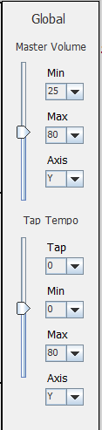

Action 1

Minimum value

Maximum value

Control axis

Action 2

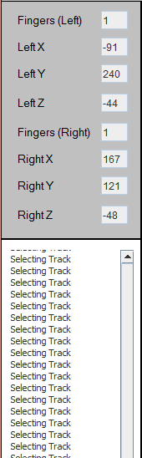

Number of left hand fingers extended

Left hand X coordinate value



Current selected track (track 17 is used for the global panel)

Status of the Leap Motion Controller

Selected MIDI output

Number of right hand fingers extended

Log window

Left hand Z coordinate value

Left hand Y coordinate value

**Controls**

Each action is performed in the following steps:

1. 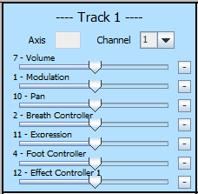Select the track

Track not selected

Track selected

Using the left hand with the index finger extended, imagine there is a grid the same size as your screen in front of you. Carefully move your finger around until the track you wish to select has turned blue – this will mean it has been selected.

Note: when you have finished selecting a track, put your index finger down to stop the app accidentally selecting a different track while you are performing an action.

1. Select the action

Using the following action table, select the action slot with your right hand using the table below:

|  |  |  |  |  |  |
| --- | --- | --- | --- | --- | --- |
| Action Slot | Thumb | Index | Middle | Ring | Pinky |
| 1 |  | Extended | Extended |  |  |
| 2 |  | Extended | Extended | Extended |  |
| 3 |  | Extended | Extended | Extended | Extended |
| 4 | Extended | Extended | Extended | Extended | Extended |
| 5 |  | Extended |  |  | Extended |
| 6 | Extended | Extended |  |  |  |
| 7 | Extended |  |  |  |  |

1. Set the action value

With a closed fist on your left hand (keep the right hand on the action) – move your hand in the direction according to the set axis to change the value of the CC command being sent through the MIDI receiver

|  |  |
| --- | --- |
| Axis | Hand direction |
| X | Up and down |
| Y | Left and right |
| Z | Forwards and backwards |

**Feedback**

Please leave your feedback at: <https://www.surveymonkey.co.uk/r/BNBMNMC> - It will be directly used in the report!